# Burak Kemal Kara - 2114734

# Hüseyin Bayrakdar - 2030294

# 1. Introduction

The aim of this project is capturing the audio signal and play the record on the speaker. To manipulate audio signal TM4C123 used. Since it already has Analog-to-Digital IC, audio captured without peripherals. But this is not the same for Digital-to-Analog operation. TM4C123 doesn’t have DAC, so external Digital-to-Analog Converter (MCP4725) will be used for this operation. Communication with DAC performed by I2C protocol. Record and play will start by button. Also, the frequency of the sampling is adjustable by potentiometer.

# 2. Overall Block Diagram

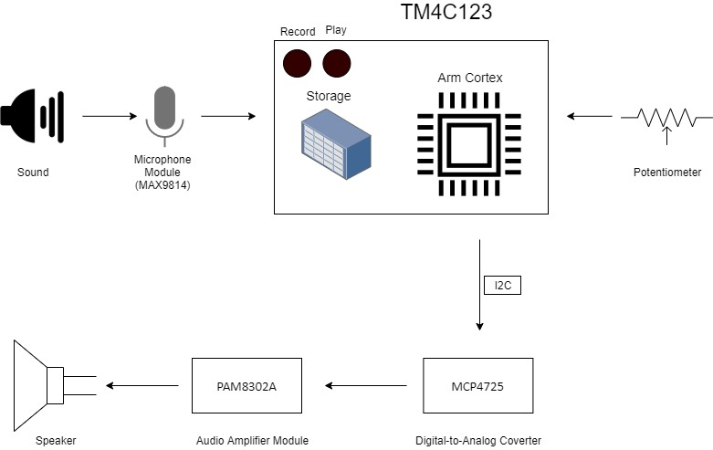

Figure 1 Overall Block Diagram

In overall analog sound captured by the MAX9814 microphone module. By using ADC in TM4C123 digitalized signal stored. Note that the storage of TM4C123 is limited. Therefore, record cannot exceed 3 seconds. ADC frequency determined by potentiometer. Around 8khz is sufficed to understand words by a human. Since TM4C123 doesn’t have DAC, sampled data send to peripheral (MCP4725) by I2C. Afterward, the signal amplified and transmitted to the speaker by the Audio amplifier module (PAM8302A).

# 3. Flowchart of the System

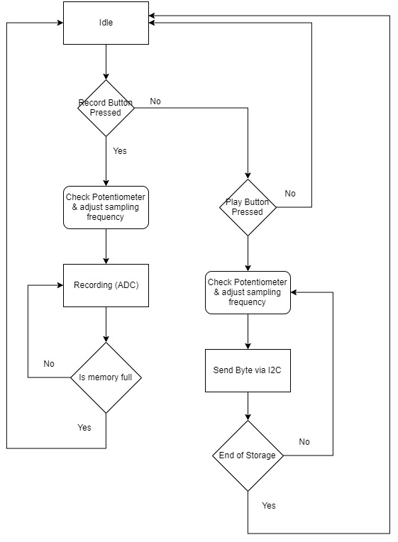

Figure 2 Flowchar of the System

# 4. I2C Serial Communication Protocol

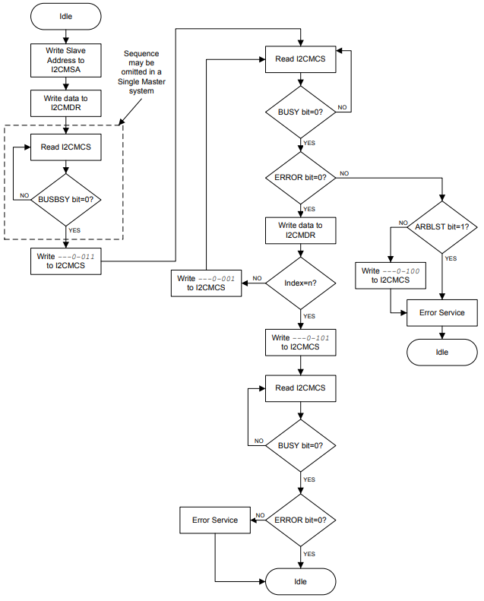

Figure 3 Flowchart of Master TRANSMIT of Multiple Data Bytes via I2C

I2C is a serial communication protocol that uses at least two pin one SCL and SDA.SCL send clock, SDA sends data of master. It sends byte with a start and stops a bit. After byte transmitted, slave sends ACK bit to master via SDA to warn master acknowledged otherwise error occurred. At the very first byte and end byte master, send start sequence and stop sequence from starting and discontinuing communication. Master sends device code, address bits, and write/read operation. Device code determines how many bits send for one data. The address bits aim is to select slaves.

# 5. Utilities

1. MAX9814 Microphone Module
2. MCP4725 I2C DAC Breakout Module
3. PAM8302A Audio Amplifier Module
4. TM4C123 Microcontroller
5. Breadboard
6. Speaker 5W
7. Potentiometer